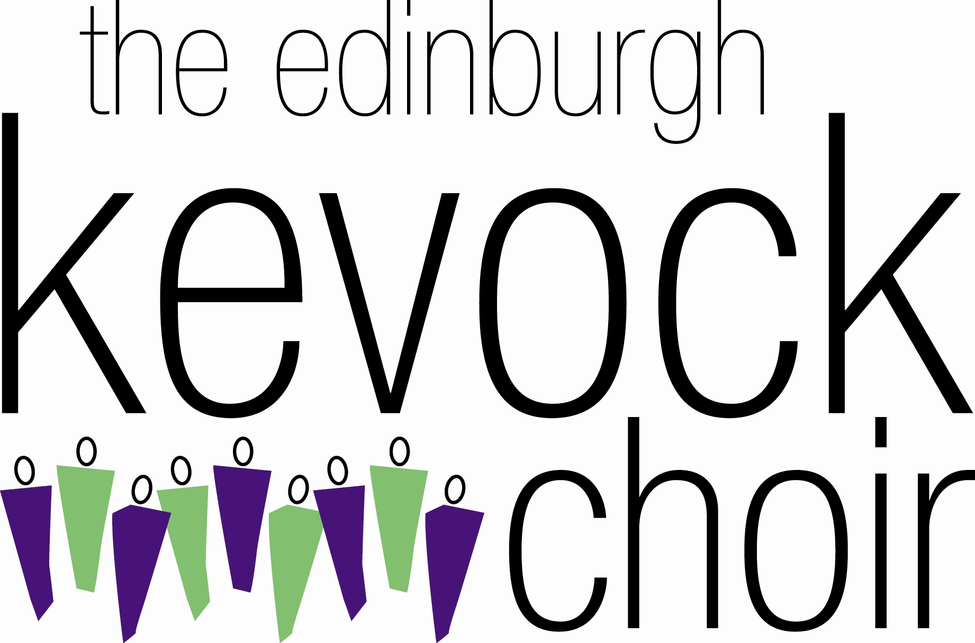

Friends and relatives of choir members can become more closely associated with the choir by becoming Friends of the Choir. Benefits of membership include:

- Advance notification of our main concerts
- Discount of £1.50 per ticket for our main concerts
- A free programme for our main concerts
- The opportunity to join in social events with choir members
- The opportunity to join the Pound Club
- Free entry in an annual draw
- Regular information about the choir
- Discount of 10% from the normal purchase price of choir CDs, etc

Single membership: £10 per annum
Joint membership: £18 per annum – covers two people, not necessarily spouses.

Complete the attached form and return it to Hilary Stokes, Secretary Kevock Choir, 20 Ravenscroft Gardens, Edinburgh, EH17 8RP, with a cheque for the appropriate amount, payable to ‘The Edinburgh Kevock Choir’

Please join us and become part of the Kevock Family.

FRIENDS OF THE EDINBURGH KEVOCK CHOIR
January – December 2016

I/we wish to become Friend(s) of the Edinburgh Kevock Choir: -

Name ______________________________________________

Address ______________________________________________

_______________________________________________________

_______________________________________________________

Telephone ______________________________________________

Email address ________________________________________

If applicable, name of joint Member: -

_______________________________________________________

I enclose a cheque payable to ‘The Edinburgh Kevock Choir’ for
£10.00 / £18.00 for single / joint Membership. I do not object to my/our details being held in computer records for the sole purpose of administration.

Signature ________________________________________________

